**Part One:** Using your prior knowledge, match the terms in the word bank to the definitions in the chart. Write your guess in the second column.

|  |
| --- |
| **Word Bank: Age of Exploration, Astrolabe, Caravel, Circumnavigate, Indigenous, Lateen sails, Magnetic Compass, New World, Northwest Passage, Telescope** |

|  |  |  |
| --- | --- | --- |
| **Definition** | **My Guess** | **Confirm or Correct** |
| (1) To sail around (the world) |  |  |
| (2) Triangular sails that allowed ships to sail into the wind |  |  |
| (3) The term used to describe North and South America after the early voyages of European explorers |  |  |
| (4) The period from 1400-1600 when Europeans sailed across the vast oceans to explore Asia, Africa, and the Americas |  |  |
| (5) A water route searched for by many explorers to India by way of the Atlantic Ocean to avoid the Ottoman Empire |  |  |
| (6) Invented in the 1100s, by the 1200s the needle pivoted on a pin over a card that showed the directions |  |  |
| (7) An optical instrument for making distant objects appear larger and therefore closer |  |  |
| (8) A person or thing native to a particular area |  |  |
| (9) A new type of ship that was strong, maneuverable, and able to sail against the wind |  |  |
| (10) Invented by the Greeks and improved by the Arabs, used to measure the angles of the sun in order to determine latitude |  |  |

**Part Two: As you watch the slide show presentation, confirm or correct your original guess in the last column.**

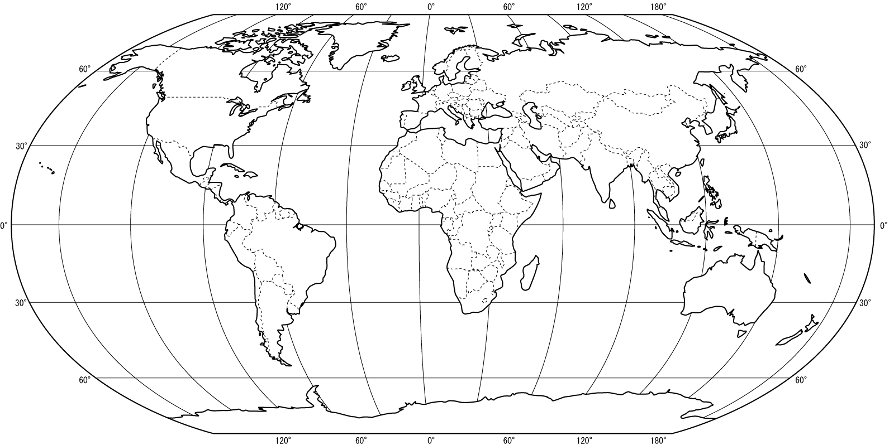

**The World Map**

**Directions: Label the SEVEN continents (Africa, Antarctica, Asia, Australia, Europe, North America, South America) and FOUR oceans (Arctic, Atlantic, Indian, Pacific)**