Cell Organelle Resources

Biology Junction Cells
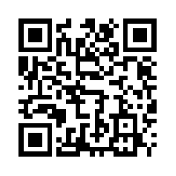
https://goo.gl/QOkSDb

Cells Alive
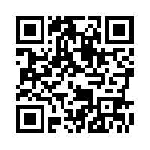
https://goo.gl/m23a19

Utah Science
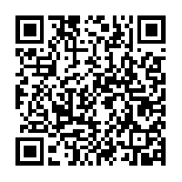
https://goo.gl/g2pDEM

Windows to the Universe
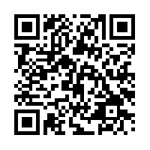
https://goo.gl/jx8QAI

Khan Academy
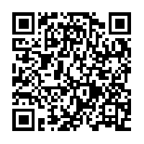
https://goo.gl/RFYG69

Cell Organelles Powerpoint
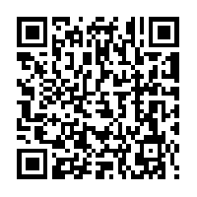
https://goo.gl/dExstj

Discovery Education
Username: wcp lunch number (no spaces)
Password: lunch number
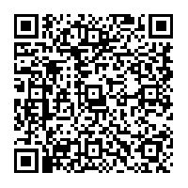

https://goo.gl/LePloh

