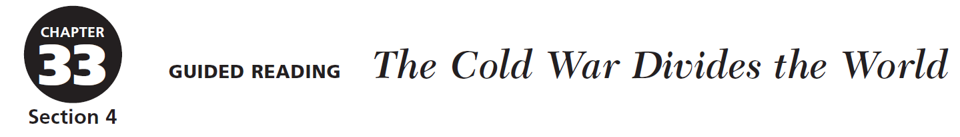
Entry #_________ Date _________________________

Main Comprehension Questions
Directions: Answer the following questions from the reading.

- What are Third World countries?

- What differing U.S. and Soviet goals led to the Cuban Missile Crisis?

- How did the Cuban Missile Crisis make the threat of nuclear war a reality for many Americans?

- Why did the United States switch its support from the Sandinistas to the Contras?

- In what ways were U.S. involvement in Vietnam and Soviet involvement in Afghanistan similar?
Following Chronological Order: As you read about conflict between the superpowers over Latin America and the Middle East, answer the questions about events listed in the timeline.

