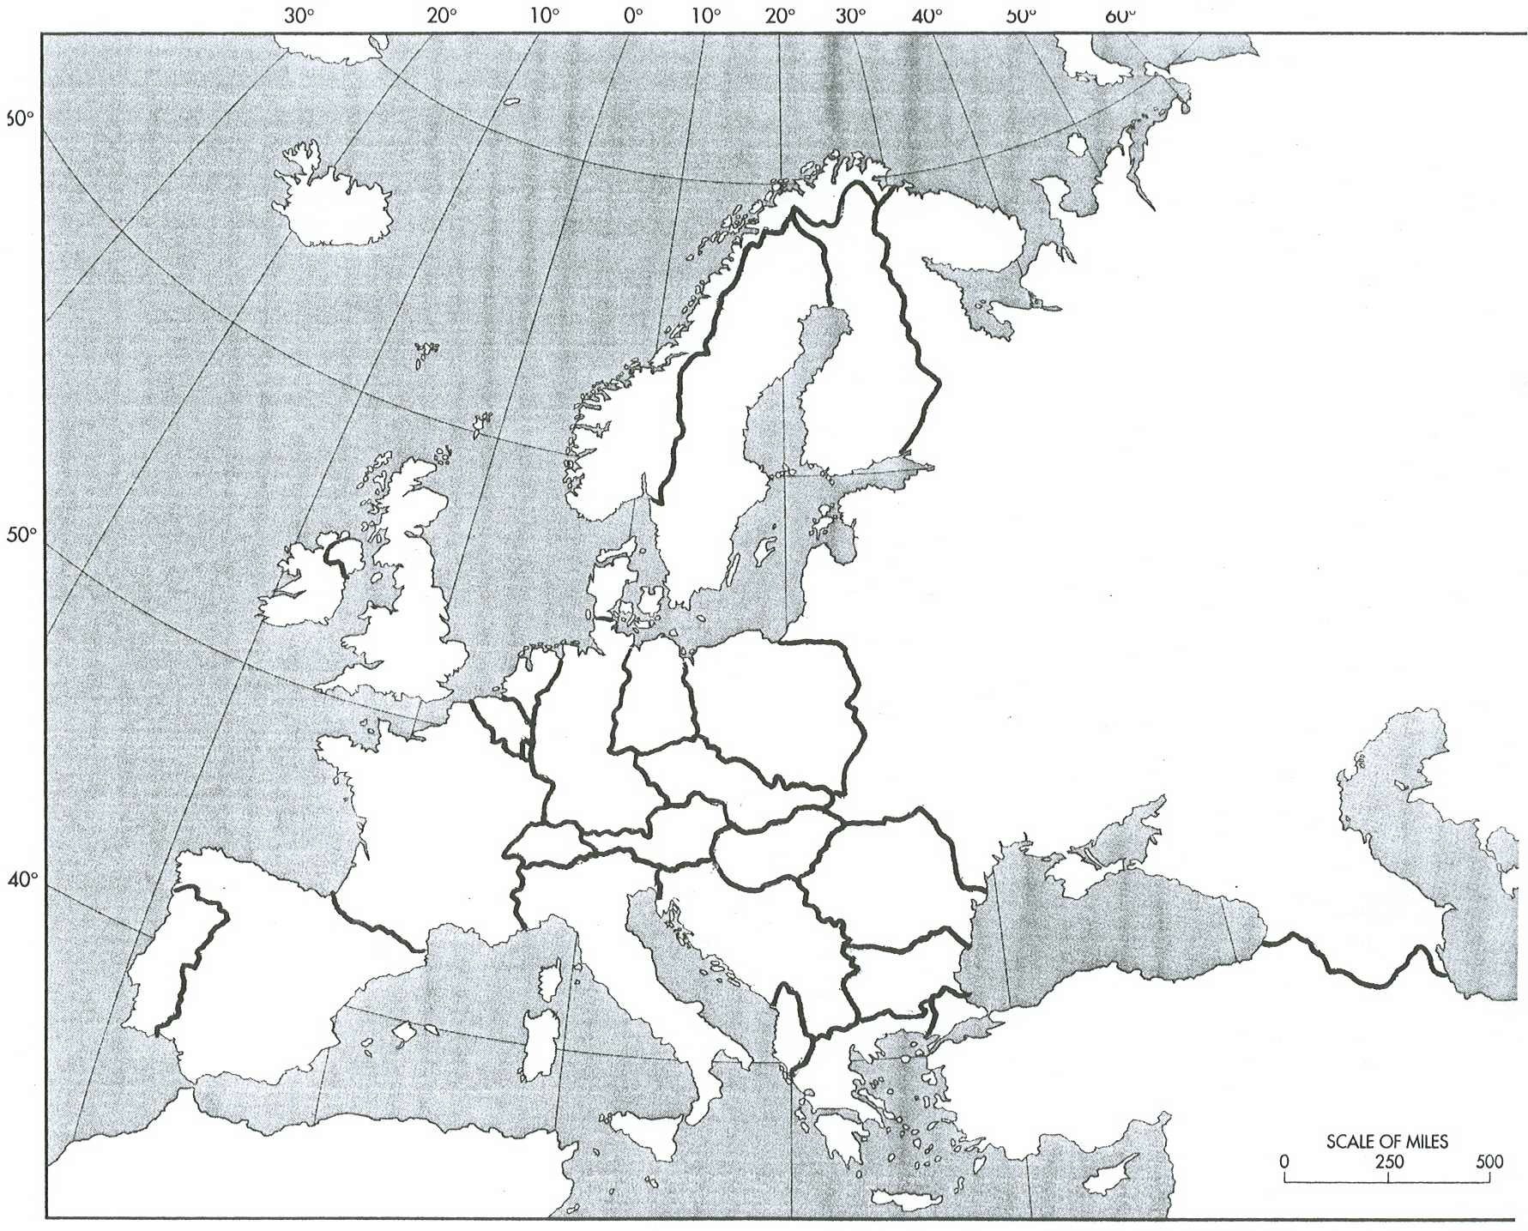

Democracies after WWII

Communist Sphere of Influence

Neutral Countries

Draw a thick PURPLE line to represent the Iron Curtain

**Countries Key**

**1 = SWITZERLAND**

**2 = ALBANIA**

**3 = LUXEMBOURG**

**4 = BELGIUM**

**5 = NETHERLANDS**

COLD WAR: MAPPING THE IRON CURTAIN

**KEY**