Entry # ______________ Date _____________________
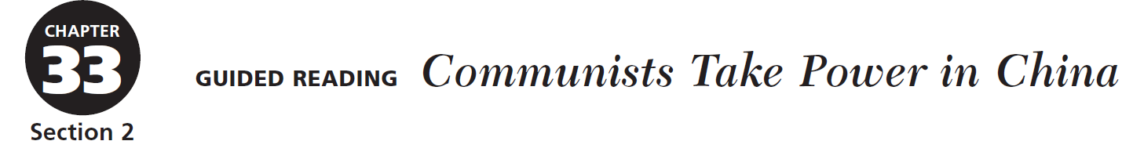

Directions: Determining Main Ideas As you read about the civil war in China and the creation of two Chinas, take notes to answer the questions below.

WHO? | Who was Mao Zedong? | Who was Jiang Jieshi?
WHEN? | When did the civil war in China resume? | When did the civil war end?
WHAT? | What advantages did Nationalist forces have? | What advantages did Communist forces have?
WHERE? | Where is Nationalist China located? | Where is the People’s Republic of China located?
HOW? | How did the superpowers react to the existence of two Chinas? | How did Mao transform the economy of China?
WHY? | Why did the Great Leap Forward fail? | Why did Mao launch the Cultural Revolution?

