Name:_____________________________
Date:______________

Unit 2 Review

Please use a separate sheet of paper if you can’t show your work in the box.

1. Jose had ³/₄ gallons of paint and used only ¹/₂ of that for a project. How many gallons of paint did he use? | 2. The cost of gas is $2.08 per gallon. Ashley buys 8.3 gallons. What is the total cost?
3. You go out for a long walk. You walk 2 ³/₄ mile and then sit down to take a rest. Then you walk ³/₈ of a mile. How far did you walk altogether? | 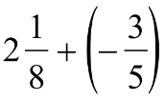  4.
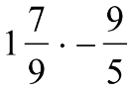  5. | 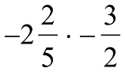  6.
7. A local chicken sandwich restaurant has 42 ²/₃ pounds of chicken. How many ¹/₃ pound chicken sandwiches can be made using all the chicken? | 8. Pam walks ⁷/₈ of a mile to school. Paul walks ¹/₂ of a mile to school. How much farther does Pam walk than Paul?
9. A school is designing a new playground. They want to use ¹/₄ of the playground for a basketball court and ³/₈ of the playground for a soccer field. How much is left for the swings and play equipment? | 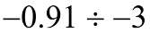  10.
11. | 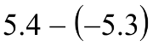  12.
13. A hippopotamus lives about 2 ⁴/₇ times as long as a tiger. A tiger lives an average of 16 years. How long does the average hippopotamus live? | 14. Compare the two numbers below using =, <, or >.
15. Convert to a fraction.  -7.008 | 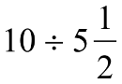  16.
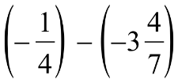  17. | 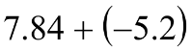  18.
19. Order the following numbers in descending order.  0.6 , -⁴/₅ , ²/_{3 ,} -1 | 20. Amy built a tower of blocks that was 36.8 centimeters high. She used 5 identical blocks to build the tower. What was the height of each of the blocks?
21. Convert to a decimal.  4 ⁵/₆ | 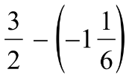  22.
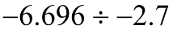  23. | 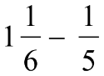  24.
25. The class was given a prize for selling the most magazines. Their prize was 16 ¹/₂ gallons of ice cream. If the students ate ¹/₃ of this before lunch, how many gallons did they eat? | 26. Patricia has $425.82 in her checking account. How much does she have in her account after she makes a deposit of $120.75 and a withdrawal of $185.90?
27. Jackie has ¹/₃ of a Hershey bar. Steven has ⁴/₁₂ of a Hershey bar. How much do they have together? | 28.
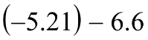  29. | 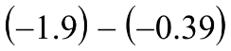  30.

