Weekly Warm-Ups - December 11-20
Name:________________________________ Core:________________

Answer the Daily Warm-Up Questions.

Monday, 12/11
State one piece of evidence that indicates that the cell shown above is an eukaryotic cell.

Tuesday, 12/12 - Fill in the blanks for each question.

- The smallest unit that can carry on all the processes of life is a _______________.
- Miniature organ-like structures that have specific functions in a cell are called _______________.
- Rough endoplasmic reticulum (ER) contains _______________ and Smooth ER does not.
- Most nuclei contain a _______________ where ribosomes are made.
- The _______________ is gel-like fluid inside the cell membrane that surrounds the organelles.
Wednesday, 12/13
- What do the letters DNA stand for?

- Where is DNA found in prokaryotic cells?

- In Eukaryotic cells?

Thursday, 12/14
- What is the shape (structure) of DNA?
- What are the sides of the DNA ladder made of?
- What are the "rungs" (steps) of the DNA ladder made of?
- How do the bases bond together? A bonds with _____ G bonds with _______
Friday, 12/15 - Label the stages of Mitosis in the onion root tip below in order. The drawings represent the images from the microscope slides to help you see the chromosomes more clearly.
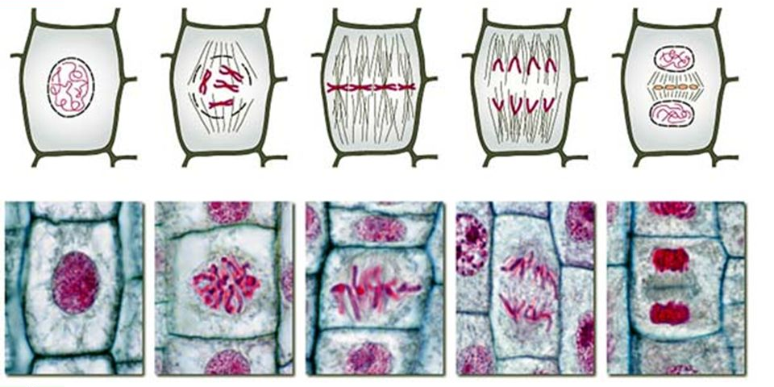

Monday, 12/18
Why do unicellular organisms undergo cell division?

Why do multicellular organisms undergo cell division?

Tuesday, 12/19
Siblings look different even though they come from the same two parents. This is because
a. All their traits come from their father.
b. All their traits come from their mother.
c. The mother’s and father’s traits combine in different ways with each child.
d. The mother’s and father’s traits combine exactly the same with each child.
Wednesday, 12/20
Login Google Classroom to complete the Warm Up Quiz.

*If you are absent, check the team website to complete the warm up question.

