**#______**

Name _______________________

Date ________________________

**DNA Reading Notes**

**Part 1: DNA Research**

|  |  |
| --- | --- |
| **Questions** | **Research Notes** |
| What do the letters DNA stand for? |  |
| What is DNA? |  |
| Where is DNA found/located? | In Prokaryotic Cells:  In Eukaryotic Cells: |
| Who are the four individuals who contributed to our knowledge of the structure of DNA? |  |
| How do Scientists describe DNA’s structure? What does it look like? |  |
| Describe the chemical structure of DNA. |  |
| What are the four Nitrgoen bases that make up DNA?  (and their abbreviations) |  |
| How do the 4 bases always pair up in a chain of DNA? |  |
| What are chromosomes? |  |
| How many chromosomes do humans have? |  |
| Draw a diagram of a chromosome. (hint: recall that from cell structures) |  |
| What are genes? |  |
| What are genes made of? |  |
| What are proteins? |  |
| What is the role of proteins? |  |
| How does DNA make a copy of itself? |  |
| What does mRNA stand for and what does it do? |  |
| What are the 4 bases in RNA? |  |
| □ Color the phosphates red (one is labeled with a "P") □ Color the deoxyriboses light blue (one is labeled with a "D") □ Color the riboses dark blue (one is labeled with a “R”) □ Color the hydrogen bonds (small circles) gray.  □ Color the thymines orange. thymine □Color the adenines green. adenine  □Color the guaninespurple. guanine □ Color the cytosines yellow.cytosine    □ Color the uracils brown. | |

**Messenger RNA**

**DNA**

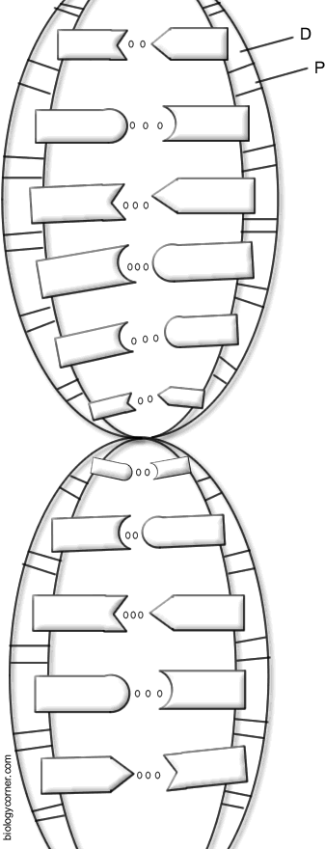 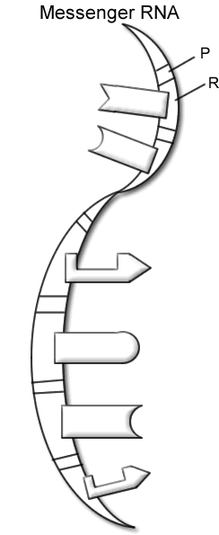

**Part 2: DNA Snapchat Story**

Use your research to tell the story of DNA. Create 8 snaps to tell the story of DNA. You may create your own snaps or use the pictures provided at your table. The story should *flow smoothly* (in a logical order, not just randomly) and demonstrate your understanding of DNA.

Using the rubric to guide the creation of your DNA story, create at least 8 (but no more than 12) snaps with text to tell the story of DNA. Pay close attention to the requirements to be sure you include all of the important information.

|  |  |  |  |
| --- | --- | --- | --- |
| **Check off as completed** | **Snapchat Story Requirements** | Point Value | **Points Earned** |
| **Content of Snaps and Text** | | | |
|  | What is DNA?   * What organisms have DNA? * Where is DNA located in cells? * What is the structure of DNA (what is it made of, what does it look like)? * What is the function/purpose of DNA? | 20 |  |
|  | What are genes?   * Where are genes located? * What is the function/purpose of genes? | 10 |  |
|  | What are chromosomes?   * Where are chromosomes located? * What is the function/purpose of chromosomes? | 10 |  |
|  | What is the relationship between DNA, genes and chromosomes? | 5 |  |
| **Snapchat Story** | | | |
|  | Story includes at least 8 (but no more than 12) snaps with text. | 10 |  |
|  | Snaps show understanding of all content requirements. | 10 |  |
|  | Snap images are relevant to the text content. | 10 |  |
|  | Snaps flow smoothly with appropriate transitions and the story is told in a logical order. | 10 |  |
|  | Snaps are neat, colorful and creative. | 15 |  |
| **Total Points** | | 100 |  |