**#___** Name_____________________________

**Energy and Electricity** Date _________________ Period ______

**Open and Closed Circuits**

1. 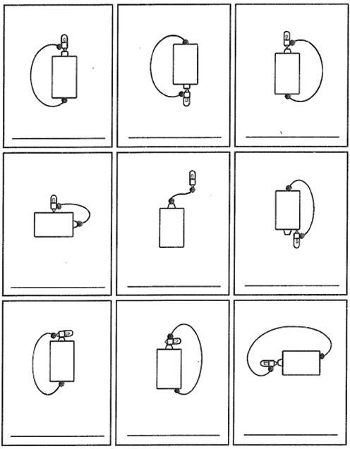Each picture shows a battery, light bulb, and wire. Decide whether each bulb will light up and write either YES or NO under each picture.
2. What is a closed circuit?
3. What is an open circuit?

**Circuit Symbols**

4. Draw the symbol for each of the circuit parts.

|  |  |  |  |  |  |
| --- | --- | --- | --- | --- | --- |
| Wire |  | Resistor |  | Bulb |  |
| Battery |  | Switch |  | Connected Wires |  |

**Series and Parallel Circuits**

5. Under each circuit diagram, circle whether the circuit is SERIES or PARALLEL.

|  |  |  |  |  |  |
| --- | --- | --- | --- | --- | --- |
|  | |  | |  | |
| Circle one:  **SERIES** or **PARALLEL** | |  | | Circle one:  **SERIES** or **PARALLEL** | | Circle one:  **SERIES** or **PARALLEL** | |

6. Explain how you can tell the difference between a series circuit and a parallel circuit.

______________________________________________________________________________________________________________________________________________________________________________

_______________________________________________________________________________________

**Circuit Diagrams**

7. **Draw** and **label** the circuit diagram for this circuit in the box to the right.

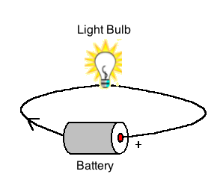

8. **Draw** and **label** the circuit diagram for this circuit.

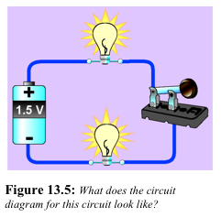

**Fill in the Blanks:**

9. The part of an atom that moves to create electricity is the ________________________.

10. The flow of electrons is called electric ___________________. This only happens if there is a complete path with no holes or gaps.

11. The loop of wire that the electrons flow through is called a _____________________.

12. A circuit in which all electrons follow a single pathway is a ____________________ circuit.

13. A circuit in which electrons follow multiple pathways is a ___________________ circuit.

14. If one light bulb goes out in a series circuit, the other light bulbs will __________ ___________.

15. What are the two things electrical current needs?

a. __________________________________________________________________________________________

b.___________________________________________________________________________________________

**Long Answer:**

16. Are household circuits connected in parallel or series? Explain your answer.

_______________________________________________________________________________________

______________________________________________________________________________________________________________________________________________________________________________

______________________________________________________________________________________________________________________________________________________________________________