Energy Transfer in the Atmosphere
Name _____________________
Date ________________ # _____

Energy from the Sun
The sun’s energy reaches Earth through the process of radiation. Radiation is the transfer of energy by electromagnetic waves. Most sunlight is visible light. Visible light is light that you can see. Visible light passes through Earth’s atmosphere. At Earth’s surface, the Sun’s energy is converted to thermal energy, commonly called heat. Ultraviolet (UV) light and infrared radiation (IR) are two other forms of radiant energy from the Sun. The wavelengths of UV and IR are just beyond the range of visibility to human eyes. UV light has short wavelengths and can break chemical bonds. A large dose of UV light will burn human skin and can cause skin cancer. Infrared radiation (IR) has longer wavelengths than visible light. You can feel IR as thermal energy or warmth. Earth absorbs energy from the Sun, and then it is radiated back as IR.

As the Sun’s energy passes through the atmosphere, some of it is absorbed, or taken in, by gases and particles. Some of it is reflected back into space. As a result, not all of the energy coming from the Sun reaches Earth’s surface. Gases and particles in the atmosphere absorb about 20 percent of incoming solar radiation. Oxygen, ozone, and water vapor all absorb ultraviolet light. Water and carbon dioxide in the troposphere absorb some infrared radiation from the Sun. Earth’s atmosphere does not absorb visible light. Visible light must be converted to infrared radiation before it can be absorbed. Bright surfaces, especially clouds, reflect radiation as it enters the atmosphere. Clouds and other small particles in the air reflect about 25 percent of the Sun’s radiation. Some of the radiation travels to Earth’s surface. There, land and sea surfaces reflect it back. About 30 percent of all radiation that enters the atmosphere reflects back into space. If 30 percent of the incoming radiation reflects back into space and the atmosphere absorbs 20 percent, only about 50 percent of incoming solar radiation reaches Earth. Earth’s surface then absorbs it.

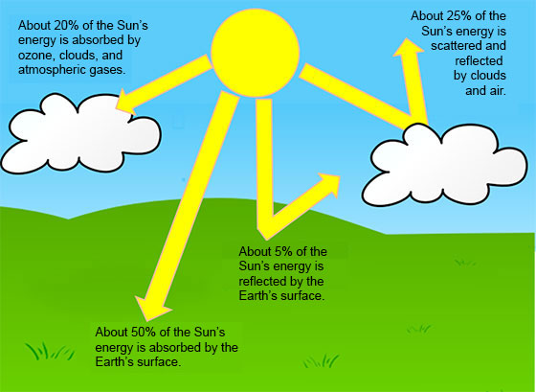

Thermal Energy Transfer
Recall from sixth grade that there are three types of thermal energy transfer—radiation, conduction, and convection. All three types of transfer occur in the atmosphere. Radiation is the process that transfers energy from the Sun to Earth. Thermal energy always moves from an object with a higher temperature to an object with a lower temperature. Conduction is the transfer of thermal energy by collisions between particles of matter. Particles must be close enough to touch to transfer energy by conduction. If you touched a pot of boiling water, thermal energy from the pot would move to your hand by conduction. Conduction occurs where the atmosphere touches Earth. As molecules of air close to Earth’s surface heat, they spread apart, and air becomes less dense. Less-dense air rises and transfers thermal energy to higher altitudes. The transfer of thermal energy by the movement of matter from one place to another is called convection. Convection occurs in the atmosphere when conduction heats air close to earth’s surface.

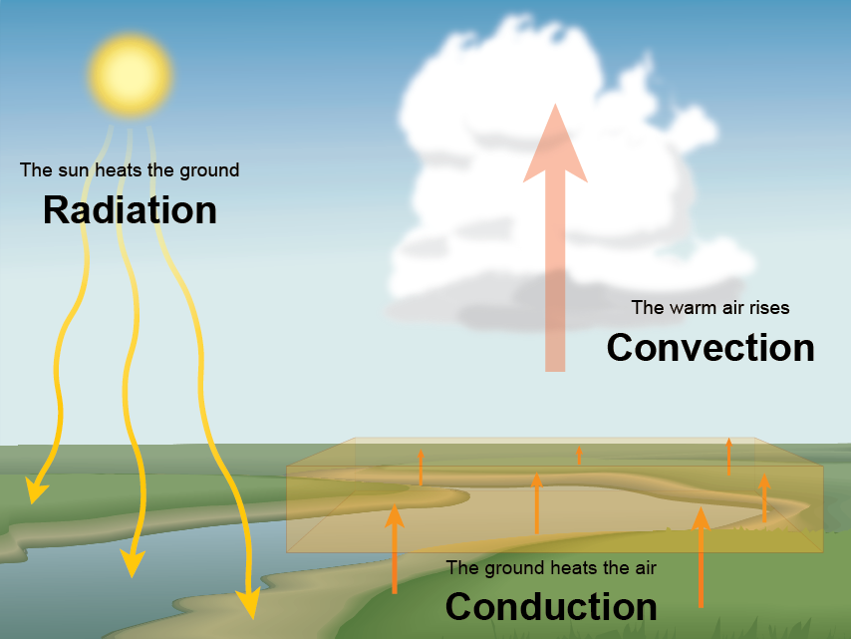

You’ve already read that energy transfers through the atmosphere by convection. On a hot day, air that is heated becomes less dense. This creates a pressure difference. Cool, denser air pushes the warm air out of the way. The more-dense air replaces the warm air. The warm air is often pushed upward. Warmer, rising air always comes with cooler, sinking air. Air constantly moves in the atmosphere. For example, wind flowing into a mountain range rises and flows over the mountains. After the air reaches the top, it sinks on the other side. Circulating air affects weather and climates around the world.

When you stand outside in the wind, your body forces some of the air to move above you. The same is true for plants, hills, cars, and buildings. Conduction and convection also cause air to move upward. Stability describes whether circulating air motions will be strong or weak. When air is unstable, circulating motions are strong. When air is stable, circulating motions are weak. Unstable conditions often occur on warm, sunny afternoons. During unstable conditions, air near the ground is much warmer than air at higher altitudes. As warm air rapidly rises, it cools in the atmosphere. Large, tall clouds form. Latent heat released as water vapor changes from a gas to a liquid, adds to the instability, and produces a thunderstorm. Sometimes, air near the ground is nearly the same temperature as air at higher altitudes. When this happens, the air is stable, and circulating motions are weak. A temperature inversion can take place under these conditions. A temperature inversion occurs in the troposphere when temperature increases as altitude increases. During a temperature inversion, a layer of cooler air close to Earth is trapped by a layer of warm air above it. Temperature inversions prevent air from mixing. This can trap pollution in the air closet to Earth’s surface.

