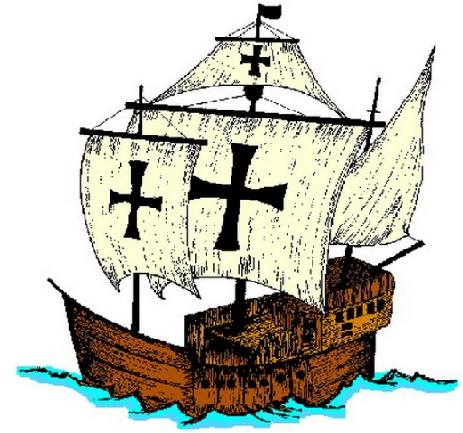
Europeans Explore the East
A story of how Portugal paved the way for the rest of Europe to discover the world.
Cast:
- Narrators A- L
- European Merchant
- Muslim Merchant
- Italian Merchant
- Bartolomeu Dias
- European Sailor
- Prince Henry
- Portuguese Sailor #1 & #2

- Dias’ Crew Member
- Vasco Da Gama
- Da Gama’s Crew Member
- Christopher Columbus
- Pope Alexander VI
- Ferdinand Magellan
- Dutch Citizen
- French Citizen

Scene I
Narrator A: Beginning around 1100, European crusaders battled Muslims for control of the Holy Lands in Southwest Asia. This was one of the first times that large groups of Europeans had experienced the culture of the East. Europeans became familiar with spices and other luxurious items from the East and wanted to find a way to bring them back to Europe after the Crusades. So, by the early 1400s, Europeans were ready to venture beyond their borders. The desire to have new sources of wealth was a main reason for European exploration. Through overseas exploration, merchants and traders hope ultimately to benefits from what had become a profitable business in Europe: the trade of spices and other luxury goods from Asia.
European Merchant: After the crusades, we continued to demand such spices as nutmeg, ginger, cinnamon, and pepper, all of which added flavor to our bland foods. Because demand for these goods was greater than the supply, merchants could charge high prices and thus make great profits.
Muslim Merchant: We normally buy Asian goods for a reasonable price and then we sell it to an Italian Merchant.
Italian Merchant: Once we buy the goods from Muslim Merchant, we bring it into Europe and sell it there for an even higher price! We definitely control trade across all the land routes of the Mediterranean region!
Narrator B: Muslims sold Asian goods to Italian merchants and the Italian merchants sold the items at increased prices to merchants throughout Europe. European Merchants definitely did not like this arrangement. Paying such high prices for the goods cut directly into their profits. In addition to finding a sea route to Asia, European explorers also felt that they had a sacred duty to convert non-Christians throughout the world. Bartolomeu Dias, an early Portuguese explorer was committed to spreading Christianity.
Bartolomeu Dias: My goal for my voyages is simple. I want to serve God and His Majesty, to give light to those who were in darkness and to grow rich as all men desire to do.
Narrator C: While “God, glory, and gold” were the primary motives for exploration, advances in technology made the voyages of discovery possible.
European Sailor: All of the new navigational technologies definitely made sailing easier! Before the age of exploration, the main problem with our ships was that they could not sail against the wind. But in the 1400s, these new ships, called caravels, were sturdier and had triangular sails, which allowed it to sail effectively against the wind.
Narrator D: Europeans also improved their navigational techniques. To better determine their location at sea, sailors used the astrolabe, which the Muslims had perfected. The astrolabe was a brass circle with carefully adjusted rings marked off in degrees. Using the rings to sight the stars, a sea captain could calculate latitude, or how far north or south of the equator the ship was.
Scene II
Narrator E: The leader in developing and applying the new sailing innovations was Portugal. Located on the Atlantic Ocean at the southwest corner of Europe, Portugal was the first European country to establish trading outposts along the west coast of Africa. Eventually, Portuguese explorers pushed farther east into the Indian Ocean. Portugal took the lead in overseas exploration in part due to strong government support. The nation’s most enthusiastic supporter of exploration was Prince Henry, the son of Portugal’s king.
Prince Henry: My dream of exploring overseas began in 1415 when I helped conquer the Muslim city of Ceuta in North Africa. Here I found trading posts with spices, gold, and jewels. After I saw the riches that Africa had, I knew that I had to reach the source of those treasures that lay farther east. I also wanted to spread the Christian faith. So, in 1419 I started a navigation school where mapmakers, instrument makers, shipbuilders, scientists, and sea captains could gather to perfect sailing and exploration.
Narrator F: Within several years, Portuguese ships began sailing down the western coast of Africa. By the time Henry died in 1460, the Portuguese had established a series of trading posts along western Africa’s shores.
Portuguese Sailor #1: After Prince Henry set up the school, many of us started to sail to Africa. We traded with the Africans for profitable items like gold and ivory. Eventually, we traded for African captives to be used as slaves. After we established ports along the African coast, we plotted for our next move- finding a sea route to Asia.
Narrator G: The Portuguese believed that to reach Asia by sea, they would have to sail around the southern tip of Africa. In 1488, Portuguese captain Bartolomeu Dias and his crew decided that they would be the first to try the journey.
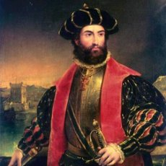
Bartolomeu Dias: My crew and I wanted to find a sea route to Asia first. That year, 1488, we made it to the tip of Africa but then a huge storm came up and battered the fleet for days. When the storm was finally over, we noticed that the storm had actually blown us around the tip of Africa and to Africa’s east coast!
Dias’ Crew Member: (excited) We couldn’t believe it! The storm had actually helped us! We continued along the southeast coast of Africa and then considered sailing to India. However, we were exhausted and food supplies were low. As a result, Captain Dias determined it would be best if we returned home.
Narrator H: With the tip of Africa finally rounded, the Portuguese continued pushing east. In 1497, Portuguese explorer Vasco da Gama began exploring the east African coast.
Vasco da Gama: In 1498, we reached the port of Calicut, on the southwestern coast of India. We were fascinated by the spices, rare silks, and precious gems that filled Calicut’s shops.
Da Gama’s Crew Member: We filled our ships with spices like pepper and cinnamon and returned to Portugal in 1499. Our cargo was worth 60 times the coast of the voyage! We were rich!
Narrator H: Da Gama’s remarkable voyage of 27,000 miles had given Portugal a direct sea route to India.
Scene III:
Narrator I: As the Portuguese were establishing trading posts along the west coast of Africa, Spain watched with increasing envy. The Spanish monarchs also desired a direct sea route to Asia in order to avoid the high prices of goods being brought from Asia by land.
Christopher Columbus: In 1492, I convinced Spain to finance a bold plan: finding a route to Asia by sailing west across the Atlantic Ocean. Even though I am Italian, Spain was the only country brave enough to take a chance on me.
Narrator J: In October of 1492, Columbus reached an island in the Caribbean. Columbus thought that he had reached the East Indies in Asia! The rest of Portugal also believed that Columbus had reached Asia. With his voyage, Columbus brought a fierce competition between Spain and Portugal in exploration!
Portuguese Sailor #2: We thought that Columbus had reached Asia and that Columbus would claim all the land that we could have claimed first!
Narrator I: The rivalry between Spain and Portugal grew more tense. In 1493, Pope Alexander VI stepped in to keep peace between the two nations.
Pope Alexander VI: I suggest that we draw an imaginary dividing line, drawn north to south, through the Atlantic Ocean. All lands to the west of the line, known as the Line of Demarcation, would be Spain’s. These lands included most of the Americas. All lands to the east of the line would belong to Portugal.
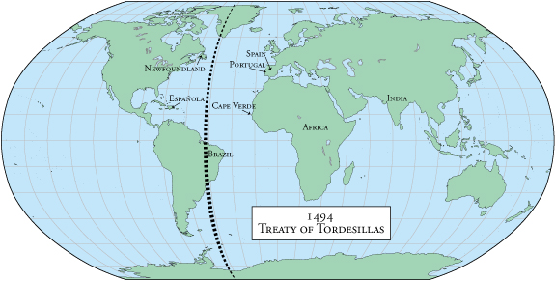
Narrator J: Portugal complained that the line gave too much to Spain. So, it was moved farther west to include parts of modern-day Brazil for the Portuguese. In 1494, Spain and Portugal signed the Treaty of Tordesillas, in which they agreed to honor the line. The era of exploration and colonization had just begun!
Scene IV:
Narrator K: With da Gama’s voyage, Europeans had finally opened direct sea trade with Asia. They also opened an era of violent conflict in the East. European nations scrambled to establish profitable trading outposts along the shores of South and Southeast Asia. And all the while they battled the region’s inhabitants, as well as each other.
European Merchant: Once da Gama cleared the way for us, we built a great trading empire throughout the Indian Ocean. We moved into that region and quickly took over the spice trade. The Muslim merchants were not too excited about that…
Narrator L: Portugal did break the old Muslim-Italian domination on trade from the East, much to the delight of European consumers. Portuguese merchants brought back goods from Asia at about one-fifth of what they cost when purchased through the Muslims and Italians. As a result, more Europeans could afford these items. In time, Portugal’s success in Asia attracted the attention of other European nations. As early as 1521, a Spanish expedition led by Ferdinand Magellan arrived in the Philippines.
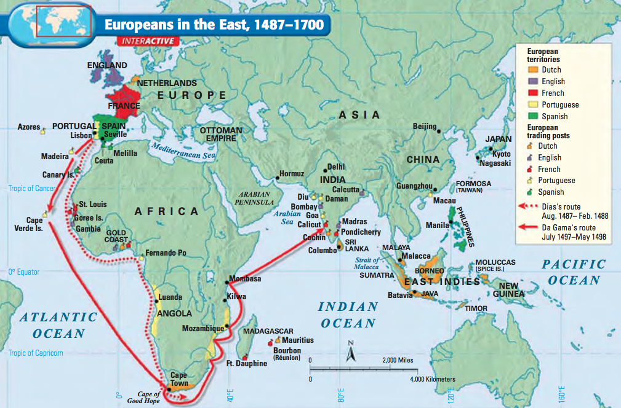
Ferdinand Magellan: We landed in the Philippines and claimed them for Spain. By 1565, Spain had begun to send people there and settle the islands. By the early 1600s, the rest of Europe had begun to descend upon Asia. They wanted to establish their own trade empires in the East.
Scene V:
Narrator A: But Spain and Portugal weren’t the only countries to start traveling to the Indies. The English and the Dutch began to challenge Portugal’s dominance over the Indian Ocean trade. By 1600, the Dutch owned the largest fleet of ships in the world- 20,000 vessels! Pressure from Dutch and English fleets eroded Portuguese control of the Asian region. The Dutch and English then battled on another for dominance of the area. In 1619, the Dutch establish their trading headquarters at Batavia on the island of Java. They slowly began to take over more and more islands, including the valuable Spice Islands that were controlled by Portugal!
Dutch Citizen: Since our country had more and more land to control, we formed an East India Company to establish and direct trade throughout Asia. This company eventually became more powerful and richer than the English East India Company and established dominance over the region. Our capital city, Amsterdam, became a leading commercial center because we had so much wealth and goods coming into our country. By 1700, we controlled Indonesia and the Cape of Good Hope on the southern tip of Africa, which was used as a resupply stop.
Narrator B: By 1700, Britain and France had also gained a foothold in the region. England had established a successful English east India Company and they focused much of its energy on establishing outposts in India. France, however, was not as lucky.
French Citizen: We developed our own East India Trading Company but we never as successful as the English. We faced numerous attacks from the Dutch and we could not carry on to make a profit.
Narrator C: European traders did take control of many port cities in the region but their influence rarely extended inland. From 1500 to 1800, when Europeans began to conquer much of the region, the peoples of Asia remained largely unaffected by European contact.

