Name ________________________________________________ Date _______________________ Period _________
The Industrial Revolution: Beginnings DBQ

Historical Context:

The Industrial Revolution refers to the greatly increased output of machine-made goods that began in England in the 1700’s within the textile industry. Before the Industrial Revolution, people wove textiles by hand. Beginning in the middle of the eighteenth century, machines did this and other jobs as well. Greatly improved farming methods resulted in an agricultural revolution that paved the way for changes in manufacturing techniques. There were many reasons why the Industrial Revolution began in England and then spread to continental Europe and North America.

Directions: The following question is based on the accompanying documents (1-9). As you analyze the documents, take into account both the source of the document and the author’s point of view. Be sure to:
- Carefully read the document-based question. Consider what you already know about this topic. How would you answer the question if you had no documents to examine?
- Now, read each document carefully, underlining or highlighting key phrases and words that address the document-based question. You may also wish to use the margin to take brief notes. Answer the questions which follow each document.
Question: Why did the Industrial Revolution begin in England?

The following documents address the reasons why the Industrial Revolution began in Europe. Examine each document carefully, and answer the question or questions that follow.
Document 1:
England Resources and Canals circa 1700

- According to the map, what resources did England have that were needed for industrialization?

Document 2

This except is from a witness description before the Factory Commission in 1833.
You have been a witness to the operative (working) class in these parts; you have seen it grow from nothing into a great body in the space of a few years: how was it recruited? … A good many from the agricultural parts…People left other occupations and came to spinning for the sake of the high wages.

- Why were factory workers available?

Document 3

The following excerpts from Adam Smith’s Wealth of Nations written in 1776 describes the assembly line used in factories.
I have seen a small manufactory (factory) of this kind where then men only were employed, and where some of them performed two or three distinct operations…They could…make among them…upwards of 48,000 pins in a day…But if they had all wrought (worked) separately and independently …they certainly could not each of them have made twenty…in a day.

- According to Smith, why were workers in a factory so productive?

Document 4

Here is an excerpt from Landmarks in English Industrial History, a book written by George Warner in 1899 (London: Blackie and Son, 1924).
England…has been fortunate in possessing the natural conditions necessary to success…We recognize that England is rich in these advantages, that she has coal and iron lying close together, that her sheep give the best wool, that her harbors are plentiful, that she is not ill-off for rivers, and that no part of the country is farther than seventy miles from the sea.

- How did geography help England industrialize?

Document 5

This excerpt if from The Industrial Revolution by Thomas S. Ashton (Oxford University Press, revised edition, 1962).
…systematic thought lay behind most of the innovations in industrial practice. Invention…rarely thrives in a community of simple peasants or unskilled manual laborers; only when division of labor has developed…does it come to harvest. The stream of English scientific thought was one of the main tributaries (causes) of the industrial revolution…discoveries in different fields of activity were linked together…

- How did innovation lead to the Industrial Revolution in England ?

Document 6
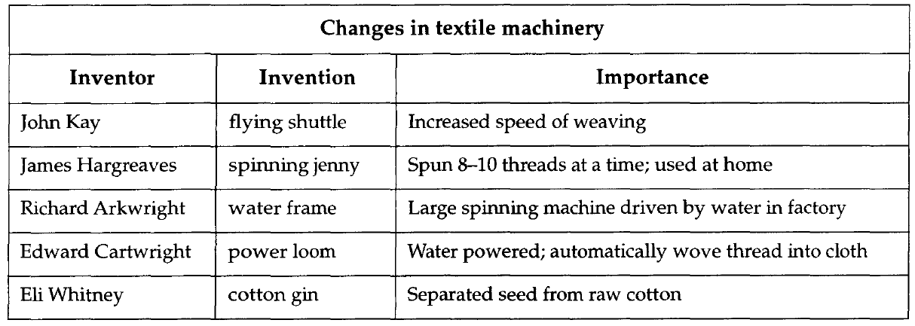

- Which three inventions were most important in increasing textile production? Explain your answer.

Document 7

- What was the result of these changes in agriculture in England?

Document 8

The following excerpt is from The Farmer’s Tour Through the East of England by Arthur Young, 1771.
As I shall leave Norfolk, it is proper to give a review of the farming methods which have made…this country so famous in the farming world…The great improvements have been made by the following methods. (1) By enclosing without the help of Parliament, (2) By introduction of a four year rotation of crops, (3) By growing turnips clover, and rye grass, (4) By the country being divided chiefly into large farms.

- How did these four changes in agriculture enable England to industrialize more easily?

Document 9

This excerpt is from The Industrial and Commercial Revolutions in Great Britain During the Nineteenth Century by L.C.A. Knowles (E.P. Dutton & Co., 1921)
When one realizes the thousands of internal tariffs that obstructed (slowed down) traffic in Germany up to 1834 and the innumerable tolls and charges that hindered trade in France before 1789…it is clear that the political and economic freedom in England was one of the causes of her industrial expansion.

- What were two reasons cited by Knowles to explain industrialization in England?

