Station # 1: Civil Disobedience Class Copy

Document 1

This excerpt is Mohandas Gandhi’s autobiography, “A Himalayan Miscalculation” (1948)
The idea came to me last night in a dream that we should call on the country to observe a general hartal (a day of fasting and prayer throughout India). Ours is a sacred fight, and it seems to me to be in the fitness of things that it should be commenced with an act of self-purification. Let all the people in India, therefore, suspend their business on that day and observe the day as one of fasting and prayer…

- How would a day of hartal affect the British colonial economy in India?
- What message does a day of hartal send to the British government?

Document 2

This excerpt is from Nelson Mandela’s Long Walk to Freedom (1994).
In early June, I was scheduled to leave on a six-week tour of Europe and North America. Before going, I met privately with (South African President) Mr. de Klerk, who wanted to discuss the issue of sanctions (an action taken by a government, in this case to limit investment and trade with South Africa, in order to exert pressure for change). Based on the changes he had made in South Africa, he asked me to mute the call for the continuation of international sanctions. While we were mindful of what Mr. de Klerk had done, in our view sanctions remained the best lever to force him to do more… I explained to Mr. de Klerk we could not tell our supporters to relax sanctions until he had completely dismantled apartheid and a transitional government was in place

- How would issuing sanctions affect the South African economy?
- According to Mandela, what would need to happen for them to stop the sanctions?

Compare and Contrast:
5. What is similar about Mandela and Gandhi’s use of civil disobedience? How did they use it differently?

Station # 2: Defiance Class Copy
Document 3

The following is an excerpt from Gandhi’s letter to Lord Irwin, English governor in India, before marching to the sea and breaking the English Salt Tax Law
Dear Friend,

Before embarking on Civil Disobedience and taking the risk I have dreaded to take all these years, I would approach you and find a way out. I cannot intentionally hurt anything that lives, must less human beings, even though they may do the greatest wrong to me and mine. Whilst therefore I hold the British rule to be a curse, I do not intend harm to a single Englishman or to any legitimate interest he may have in India… and why do I regard the British rule a curse?...Even the salt the peasant must use to live is so taxed as to make the burden fall heaviest on him… The tax itself still more burdensome on the poor man when it is remembered that salt is the one thing he must eat more than a rich man…
My ambition is no less than the convert the British people through nonviolence, and thus make them see the wrong they have done to India… But if you cannot see your way to deal with these evils… I shall proceed with such coworkers of the Ashram as I can take, to disregard the provisions of the Salt laws….

- Why do you think Gandhi wrote this letter to Lord Irwin telling him about the Salt March in advance?
- How does the Salt March represent an act of civil disobedience?

Document 4

This excerpt is from Nelson Mandela’s Long Walk to Freedom (1994).
We also discussed whether the campaign (for Defiance of Unjust Laws) should follow Gandhian principles of nonviolence, or what the Mahatma called satyagraha, a nonviolence that seeks to conquer through conversion.
Some argued for nonviolence on purely ethical grounds, saying it was morally superior to any other method… Others said that we should approach this issue not from the point of view of principles but tactics, and that we should employ the method or tactic demanded by the conditions. If a particular method enabled us to defeat the enemy, then it should be used. In this case, the state was far more powerful than we, and any attemps at violence by us would be devastatingly crushed. This made nonviolence a practical necessity rather than an option.

- According to Mandela, what made nonviolence necessary?

Station # 3: Discipline Class Copy

Document 5

This excerpt is Webb Miller, a foreign correspondent who was present during the Dharasana Salt Works raid.
Mme. Naidu (Gandhi’s future replacement) called for prayer before the march started and the entire assemblage knelt. She exhorted them: “Gandhi’s body is in jail but his soul is with you. India’s prestige is in your hands. You must not use any violence under any circumstances. You will be beaten but you must not resist; you must not even raise a hand to ward off blows.”

In complete silence the Gandhi men drew up and halted 100 yards before the stockade… Suddenly, at a word of command, scores of native police rushed upon the advancing marchers and rained blows on their heads with their steel-shod [clubs]. Not one of the marchers even raised an arm to fend off the blows…. The survivors without breaking ranks silently and doggedly marched on until struck down…. The blankets used as stretchers were sodden with blood.

- What message do you think this act of civil disobedience sent to the British people of colonial India?

Document 6

This excerpt is from Nelson Mandela’s Long Walk to Freedom (1994).
I explained to a group of several hundred Africans, Indians and Coloured that volunteering (for the Defiance of Unjust Laws campaign) was a difficult and even dangerous duty, as the authorities would seek to intimidate, imprison, and even attack the volunteers. No matter what the authorities did, the volunteers could not retaliate; otherwise they would undermine the value of the entire enterprise. They must respond to violence with nonviolence; discipline must be maintained at all cost.

- Why is discipline an important part of civil disobedience?
- What did Mandela mean when he stated that retaliation would “undermine the value of the entire enterprise?

Compare and Contrast:
- Based on the two documents, do you believe Mandela was a follower of Gandhi? Why or why not?

Station # 4: Cartoons Class Copy

Document 7
The following is a political cartoon drawn of Gandhi. A foreign journalist is interviewing Gandhi, who has stuck his head in the British Lion’s gaping mouth. The journalist says: “My dear Gandhi, it is dangerous to put your head in the lion’s mouth at this juncture.” Gandhi replies: “Oh, my friend, the tired lion can scarcely bite off my head.”

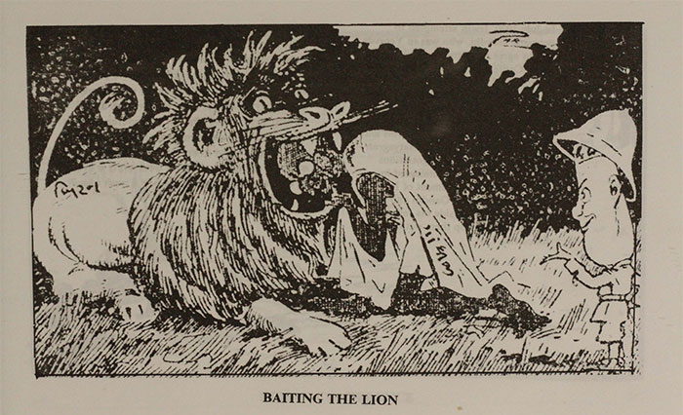

- Who is the lion portraying in this cartoon?
- What does the caption of the cartoon mean when the journalist says “My Dear Gandhi, it is dangerous to put your head in the lion’s mouth at this juncture”?
- Why would Gandhi describe the lion as being “tired”?

Document 8
Nelson Mandela cartoon

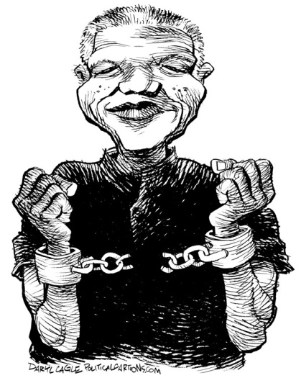

- What does this cartoon portray?
- Based on the two cartoons, what sacrifices did Mandela and Gandhi make for their causes?

Station # 5: Imprisonment Class Copy

Document 8
Mandela in prison

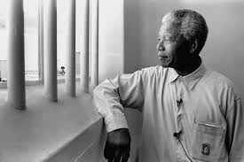

- Based on Mandela’s facial expression/body language, how do you think he feels about being imprisoned?
- Why do you think the South African government would imprison Mandela?

Document 7
Gandhi in prison
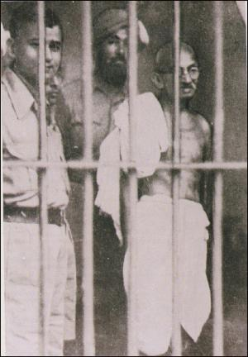

- Why do you think the British Indian government would imprison Gandhi?
- What message does Gandhi’s imprisonment send to the Indians? What message does it send to the British?

Compare and Contrast
- What sacrifices did both Gandhi and Mandela make in order to help their causes?
Station # 6: Followers Class Copy

Document 9
This photo shows Mandela driving in a car after being released from prison

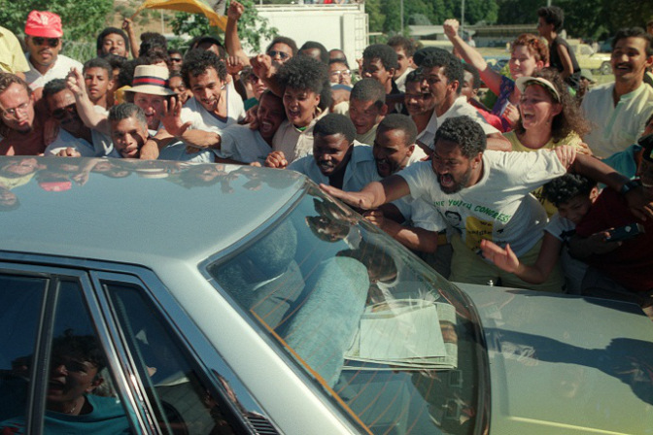

- Based on the picture, how do you think the people feel about Mandela?
- Based on the picture, why do you think the government decided to release Mandela?

Document 10
Gandhi speaking to a group of his followers
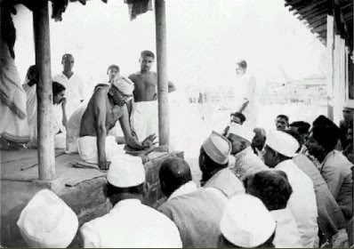

- Why do you think Gandhi appealed to so many Indians?

Compare and Contrast
- Do you think that the followers of Gandhi would agree with Mandela’s actions in South Africa? Why or why not?

