Name: ________________________ Date: ________________ Period: _______
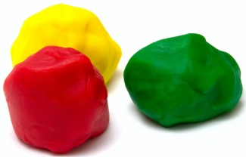
Play-Doh Math
- Take a piece of Play Dough and form it into the following shapes.
- Use the paper clip to slice through your prism.
- Draw the two-dimensional shape of each cross-section, and tell me what shape it is.

Parallel Cross Section

Perpendicular Cross Section

Corner Cross Section

Parallel Cross Section

Perpendicular Cross Section

Corner Cross Section

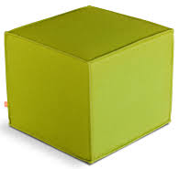
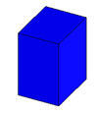

Parallel Cross Section

Perpendicular Cross Section

Diagonal Cross Section

Parallel Cross Section

Perpendicular Cross Section

Diagonal Cross Section

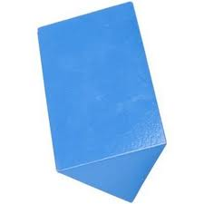
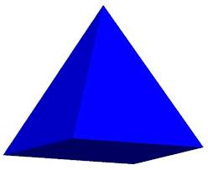

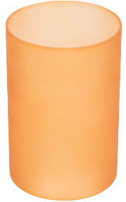
Parallel Cross Section

Perpendicular Cross Section

Diagonal Cross Section

