Weekly Warm-Ups - November 27-December 7
Name:________________________________ Core:________________
Answer the Daily Warm-Up Questions.
Monday, 11/27
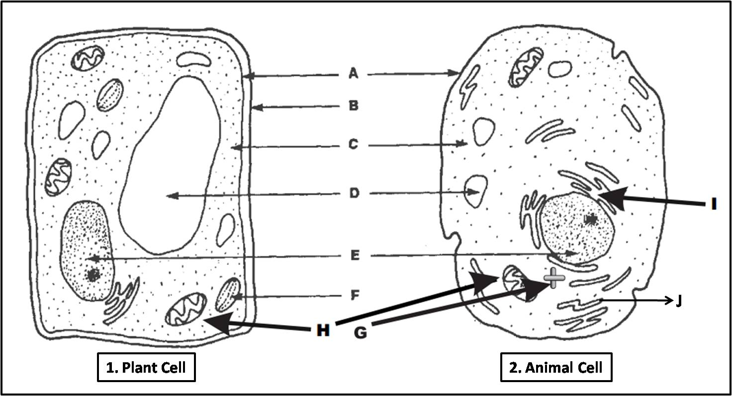
Label the structures according to the diagram.

A._______________________________ G. Centrioles
B._______________________________ H. _____________________________
C._______________________________ I. ______________________________
D._______________________________ J. ______________________________
E._______________________________
F._______________________________
Tuesday, 11/28 - List 3 ways animal and plant cells are alike.
-

-

-

List 3 ways animal and plant cells are different.
-
-
-
Wednesday, 11/29-
Pseudopodia, cilia and flagella are protist structures for _______.
A. digestion B. reproduction C. movement D. defense
Thursday, 11/30 - List the 3 statements of the cell theory.
1.
2.
3.
Friday, 12/1 -
- mitochondria ____ A. Allows material to pass in and out of the cell
2. nucleus ___ B. Transports materials throughout the cell
3. vacuole ___ C. Produces energy for the cell
4. cell membrane ____ D. Controls and regulates all activities of the cell
5. endoplasmic reticulum ___ E. Stores water, food, waste and other materials
6. chloroplast ___ F. Digests food, old cell parts, and even whole cells
7. lysosome ___ G. Makes food for the cell through photosynthesis

Monday, 12/4 -
Which two organisms contain chloroplasts and eyespots?
A. amoeba and paramecium B. paramecium and volvox
C. volvox and euglena D. euglena and amoeba
Tuesday, 12/5 -
What type of cell contains a membrane-bound nucleus or organelles, like protists or plant and animal cells?
A. Prokaryotic B. Eukaryotic C. Multi-cellular D. Unicellular
Wednesday, 12/6- Label the protist diagrams.
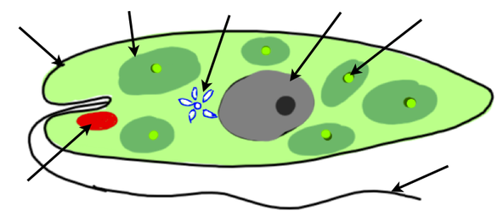
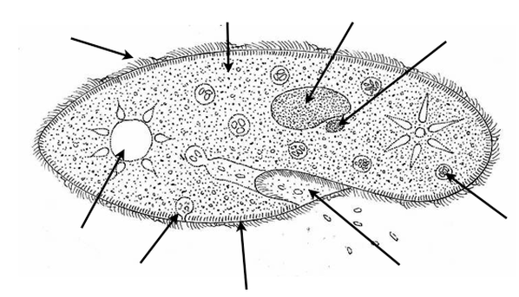
Thursday, 12/7
Login Google Classroom to complete the Warm Up Quiz.

*If you are absent, check the team website to complete the warm up question.

