Weekly Warm-Ups - October 23 - November 3
Name:________________________________ Core:________________
Answer the Daily Warm-Up Questions.
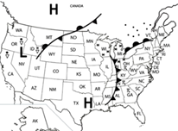
Monday, 10/23 -
- What type of front stretches from Utah to Canada?

2. What direction is the cold front traveling?

3. What type of pressure system is located over Texas?

4. What type of weather are residents of Texas
experiencing with this pressure system?

Tuesday, 10/24 -
______ 1. Evaporation A. The condition of the atmosphere at a particular time and place.
______ 2. Coriolis Effect B. The process by which liquid water changes to a gas.
______ 3. Trade winds C. A gas that protects Earth by blocking most of the sun’s harmful
rays.
______ 4. Ozone D. Warm steady winds that blow toward the equator. Used by
trading ships.
______ 5. Weather E. The shifting of global winds caused by Earth’s rotation.

Wednesday, 10/25 -
______ 1. Condensation A. A huge body of air that has similar temperature,
humidity and air pressure

______ 2. Conduction B. The boundary where air masses meet.
______ 3. Humidity C. When water vapor in the air condenses into tiny water
droplets.
______ 4. Air mass D. The transfer of heat energy by direct contact.
______5. Front E. A measure of the amount of water vapor in the air.
Thursday, 10/26 - What type of air mass brings cold, dry weather?

What type of air mass brings warm, moist weather?

Friday, 10/27 - Draw the symbol for each of the following fronts:
Cold Front -

Warm Front -

Stationary Front -

Occluded Front -

Monday, 10/30 -
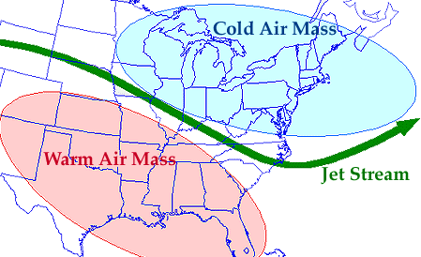

Describe the weather over NC using the jet stream in your answer.

Tuesday, 10/31 - Teacher Workday
Wednesday, 11/1 - Which of the following factors would most likely cause a hurricane to decrease in
strength?
- Staying over warm water for a long period of time.
- Increasing the number of large cumulonimbus clouds.
- Moving towards tropical waters.
- Moving over land or a continent.
Thursday, 11/2 - Tornadoes form in what type of cloud?
- Cirrus
- Cumulonimbus
- Nimbus
- Stratus
Friday, 11/3 - Login Google Classroom to complete the Warm Up Quiz.
*If you are absent, check the team website to complete the warm up question.

