Weekly Warm-Ups - October 9-20
Name:________________________________ Core:________________
Answer the Daily Warm-Up Questions.
Monday, 10/9 - Which explains why most of the rain that falls comes from the ocean?
- The majority of evaporation takes place over the ocean.
- The majority of precipitation takes place over the ocean.
- Most rivers deposit freshwater into the ocean.
- Most clouds form near or over the ocean.
Tuesday, 10/10 - How are the layers of the atmosphere primarily classified?
- By density
- By temperature
- By air pressure
- By altitude
Wednesday, 10/11 - What is the effect of the water cycle on the Earth and its atmosphere?
- The movement of water between the upper and lower layers of the atmosphere creates air pressure.
- The movement of water through the different parts of the water cycle creates weather.
- The movement of water through the different parts of the water cycle creates new water.
- The movement of water through the water cycle stops once the water reaches the ocean.
Thursday, 10/12 - Explain how the uneven heating of Earth’s surfaces causes wind.
Friday, 10/13 - Illustrate what happens to air when it is heated and cooled. Explain how this related to the air’s density?

Monday, 10/16 - What two factors are needed to measure wind?
- Direction and speed
- Temperature and speed
- Direction and temperature
- Speed only
Tuesday, 10/17 - A sea breeze blows from the ocean toward the shore. Why does this occur?
- High pressure over the land causes a downdraft to occur.
- The tide carries the wind to the shore as it moves back and forth.
- Conduction of heat from the warm water produces wind from the ocean.
- Air over land heats faster than air over water, which causes convection.
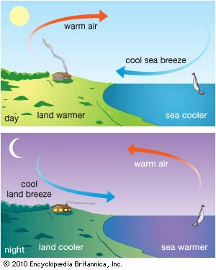
Wednesday, 10/18 - The Prevailing Westerlies and the jet stream are major wind belts over the continental U.S. Which direction do they generally move air masses?
- East to West B. West to East C. North to South D. South to North
Thursday, 10/19 - Use the diagram to answer the question.
What are the temperature and humidity of air mass B?
- Cold and dry. B. Warm and moist. C. Cold and moist. D. Warm and dry.
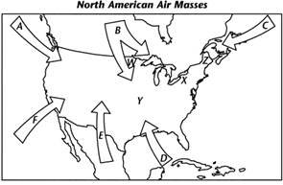
Friday, 10/20 - Login Google Classroom to complete the Warm Up Quiz.

*If you are absent, check the team website to complete the warm up question.

