Name: _____________________________ Period: __________ Date: ___________

Compositions Practice

Draw the images of triangle ABC after each composition of transformations. Record the ending coordinates.

- Triangle ABC is translated 2 units right and 3 units up. Then it is dilated by a scale factor of 2.

- Triangle ABC is rotated 90 degrees counterclockwise. Then it is reflected over the x-axis.

- Triangle ABC is rotated 90 degrees counterclockwise. Then it is translated (x, y) → (x + 6, y - 5). Finally it is reflected over the line x = -2.

- Triangle ABC has vertices A(3, 2), B(-1, -3), and C(2, -1). Find the coordinates and draw the figure after a translation of (x, y) → (x + 3, y) and a reflection over y = 1.

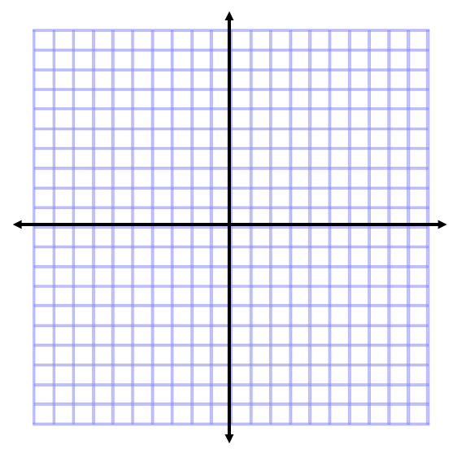

- Describe the rule for the composition of transformations below.

