Name:_______________________ Date:________

**Dilations Practice**

Find the coordinates of the vertices of each figure after the given transformation.

1. **Dilation of 4**  2. **Dilation of ½**

I (-1, 4), M (-1, 1), B (2, 4) A (6, 2), B (4, 1), C (-8, -4)

I’ A’

M’ B’

B’ C’

3. **Dilation of 3.5** 4. **Dilation of ¼**

D (2, 4), E (5, -2), F (-1, -4) Q (-4, -2), P (-8, 4), R (-3, 8)

D’ Q’

E’ P’

F’ R’

Graph the image of the figure using the transformation given.

5. **Dilation of 3** 6. **Dilation of $\frac{1}{3}$**

J (-1, -1), U (1, 3), W (0, -2) X (-6, 6), Y (-3, -6), Z (3, 3)

J’ X’

U’ Y’

W’ Z’

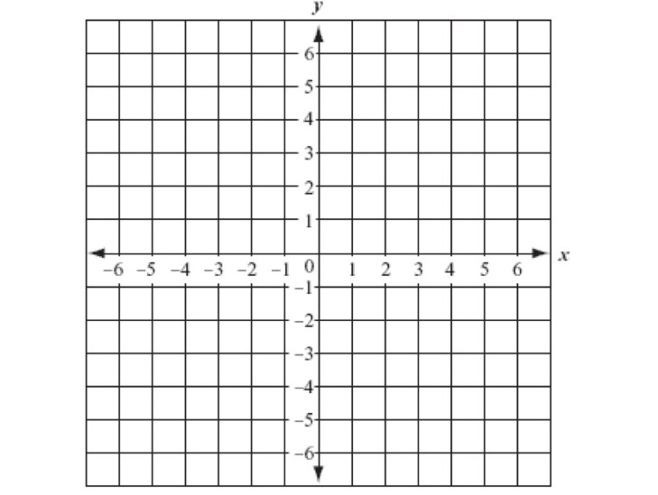 

Write a rule to describe the each transformation.

7. 8.

K (-1, -2), U (-2, 2), V (2, 2), Q (2, -1) W (0, -2), X (-8, 4), Y (-4, 0), Z (-6, 3)

to to

K’ (-2, -4), U’ (-4, 4), V’ (4, 4), Q’ (4, -2) W’ (0, -1), X’ (-4, 2), Y’ (-2, 0), Z’ (-3, 1.5)

**Scale Factor:** **Scale Factor:**

9. 10.

 

**Scale Factor:** **Scale Factor:**