Name: __________________________________ Date:__________ Core:____

Proportional Relationships in Graphs

**Determine if the given ordered pairs create proportionality. If proportional, determine the unit rate. If not proportional write N/A for the unit rate.**

1. (2 , 8) and (4 , 60)

**2.** (1.5 , 6) and (3.5 , 21)

**3.** (7 , 16.8) and (10 , 20)

**Determine if the given graphs represent proportional relationships. Explain why or why not.**

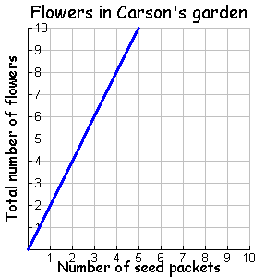

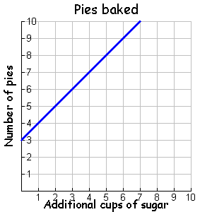

**4. 5.**

**For every 6 cups of grape juice, mix in 3 cups of strawberry juice.**

|  |  |
| --- | --- |
| **Cups of grape juice**  **(x)** | **Cups of strawberry juice (y)** |
| 6 | 3 |
| 2 |  |
|  | 2 |

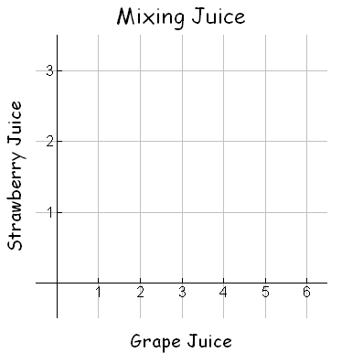**6.** What is the constant of proportionality?

**7.** What is the ordered pair where x=1? (1, _____)

**8.** Write an equation relating strawberry juice (y) and grape juice (x).

**9.** You want to make a different sized batch of juice that has the exact same flavor as your original batch. If you use 23 cups of grape juice, how many cups of strawberry juice do will you need? Use your equation to find the missing amount.

**10.** You want to make a different sized batch of juice that has the exact same flavor as your original batch. If you use 19 cups of strawberry juice, how many cups of grape juice do will you need? Use your equation to find the missing amount.

**The Jones family drives 200 miles in 5 hours. The Grant family drives 360 miles in 6 hours.**

**11.** Complete the table for each family, and graph each family’s rate on the coordinate plane.

|  |  |  |  |  |
| --- | --- | --- | --- | --- |
| **JONES FAMILY** | |  | **GRANT FAMILY** | |
| **Hours (x)** | **Miles (y)** |  | **Hours (x)** | **Miles (y)** |
|  |  |  |  |  |
|  |  |  |  |  |
|  |  |  |  |  |
|  |  |  |  |  |

12. Jones family unit rate: __________

13. Grant family unit rate: __________

14. Which family is driving faster and how do you know?

**Lines A, B, and C are proportional. Match them with their corresponding graphs.**

15. 16. 17.