Name: __________________________ Date: ___________
Spiral Review Quarter 2 Week 6 Period: _________

Answers

1) 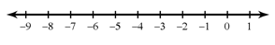

2)

3) 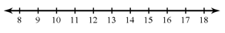

4) _______________

5) _______________

6) _______________

7) _______________

8) _______________

9) _______________

10) ______________

1. Solve and graph on a number line.  $\frac{x}{4}+4<3$ | 2. Solve and graph on a number line.  $4\left(3a-5\right)<-80$
3. Solve and graph on a number line.  $-15≤-3-x$ | 4. Find the value of x.  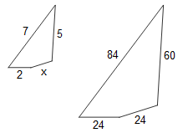
5. For every 2 red marbles there are 7 blue marbles in a bag of marbles. How many blue marbles would there be in a bag of 117 marbles? | 6. The Crayola Crayon company can make 2,400 crayons in 4 minutes. How many crayons can they make in 15 minutes?
7. If the rectangle below is enlarged using a scale factor of 2.5, what will be the perimeter of the new rectangle?  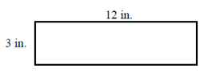 | 8. Amanda’s school has a total of 462 seventh grade students. There are 3 technology classes, each with 22 seventh grade students. What is the ratio of seventh grade students taking a technology class to all seventh grade students?
9. A girl that is 4 feet tall is standing next to the Empire State Building in New York City. The girl’s shadow is 3.2 feet long. If the Empire State Building is 1454 feet tall, how long would its shadow be? | 10. Brett made a scale drawing of a rectangular room in his house. The actual length of the room is 12 4/5 ft. The scale used to make the drawing was ¼ in. = 1 ft. What is the length of the room on the drawing?
Weekly Warm-Up’s

Monday | Tuesday
Wednesday | Thursday
Friday | Important Information

