Name: __________________________ Date: ___________
Spiral Review Quarter 4 Week 5 Period: _________

Answers

- ______________

- _______________

3) _______________

4) _______________

5) _______________

6) _______________

7) _______________

8) _______________

9) _______________

10) ______________

1. While visiting Chicago, Jenny used a taxi for transportation. The taxis charged her $.95 per city block. If the taxis charged her a total of $25.65 for transportation, how many total city blocks did she travel? | 2. A rectangle’s length is three more than two times its width. If the perimeter of a rectangle is 66 feet, what is the measurement of the length?
3. Which expression is NOT equivalent to  ½(8p – 14) – 10p?  - 4p – 7 – 10p  - -7 + (-6p)  - 4p – 7 – 5p  - -6p – 7 | 4. You decide to tile your hallway, which is shaped like a rectangle with dimensions of 14 ½ ft. by 4 ½ ft. If the tiles are square with a side length of 6 inches, how many tiles will you need to cover the hallway floor?
5. Susan is going to flip a coin and then draw one card from a standard deck. What is the probability that the coin lands heads up and the card is a queen? | 6. Simplify: 8(-2x - 3) – ¾(8x –4)
7. What is the solution set for the inequality 4(p – 3) – 12p ≥ 36 | 8. The perimeter of the quadrilateral WXYZ is 82 inches. What is the length of segment XY?  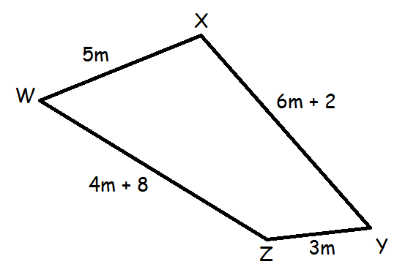
9. Write the verbal inequality numerically.  The product of 15 and a number, increased by 8 is at most 44. | 10. What is the value of the following expression?  $$\frac{1}{4}∙3\frac{2}{5}∙6\frac{7}{8}$$

Weekly Warm-Up’s

Monday | Tuesday
Wednesday | Thursday
Friday | Important Information

