# ____
Name _____________________
Date _____________
Severe Weather Stations
Station 1: Hurricanes
Hurricane Tracking – Follow the directions on the “Hurricane Tracking” page to complete the map.

Use the hurricane map you created to answer the following questions.

1. Observe the paths of Hurricane Matthew and Hurricane Harvey, describe what happens to a hurricane after it strikes land. Explain why a hurricane changes after it strikes land.
__________________________________________________________________________________________

__________________________________________________________________________________________

__________________________________________________________________________________________

2. What is the general direction a hurricane takes when it develops in the Atlantic Ocean?
__________________________________________________________________________________________

3. Compare and contrast the paths and intensity of the two hurricanes.

4. If you had been working at the National Hurricane Center when Hurricane Harvey struck, which cities or areas would you have evacuated?
__________________________________________________________________________________________

__________________________________________________________________________________________

5. What day would you have requested the evacuation? Explain why.
__________________________________________________________________________________________

__________________________________________________________________________________________

__________________________________________________________________________________________

Use the Hurricanes reading to complete the following questions.

6. What is a hurricane? _______________________________________________________________________

________________________________________________________________________________________

7. How does a hurricane form? ________________________________________________________________

________________________________________________________________________________________

8. When do hurricanes occur? _________________________________________________________________

_______________________________________________________________________________________

9. Hurricane names are reused on a six-year rotation. What would cause a name to be retired and replaced?

________________________________________________________________________________________
10. Describe the stages of tropical cyclone development.

Stage of Development | Description
Tropical Wave
Tropical Disturbance
Tropical Storm

11. Complete the Hurricane classification scale:

_________________- __________________ Hurricane Scale

Category | Wind Speed (mph) | Type of Damage
1
2
3
4
5

12. List 4 factors associated with hurricanes that make them so dangerous? Use specific examples to explain
why each one is such a problem.

Hurricane danger | Explanation of danger with specific examples
High winds

Storm Surge

Flooding

Indirect effects (long term power outages, lack of
water/food/medical care)

Station 2: Tornadoes

Tornado Frequency Mapping
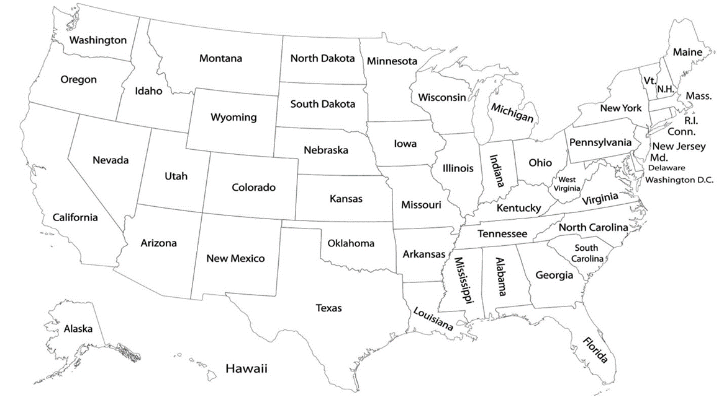
Follow the directions on the “Tornado Frequency Mapping” page to complete the map below.

Use the Tornado reading to answer the following questions.

- How many states have an average of 0-10 tornadoes per year?_______ an average of 11-20? _______
- How many states have an average of 21-37 tornadoes per year?_______ an average of more than 38? ___
- The area of the United States that seems to be most prone to tornadoes is called Tornado Alley. Most tornadoes, especially severe tornadoes, have struck here. Use the data you have compiled to name the states that are included in Tornado Alley. ____________________________________________________
_______________________________________________________________________________________
- What kind of conditions lead to the formation of tornadoes? What kind of clouds do tornadoes come from? _________________________________________________________________________________
_______________________________________________________________________________________

_______________________________________________________________________________________
- What are five danger signs associated with tornadoes?
a. _____________________________________________________________________________________
b. _____________________________________________________________________________________
c. _____________________________________________________________________________________
d. _____________________________________________________________________________________
e. _____________________________________________________________________________________
- Compare and contrast an EF 0 Tornado and an EF 5 Tornado.

- Compare and contrast a Tornado Watch and a Tornado Warning.

- What time of year do most tornadoes occur? Where do most tornadoes occur? ______________________
_______________________________________________________________________________________
Station 3: Thunderstorms and Floods

Thunderstorms and Lightning

Use the Thunderstorms and Lightning Reading to answer the following questions.

1. What is a thunderstorm?

2. Over _______________ thunderstorms occur throughout the world each day.

3. During what time of year and during what time of day are thunderstorms most likely to occur?

4. What 3 ingredients create a thunderstorm?

5. Explain why hail forms in thunderstorm or cumulonimbus clouds, but not in nimbostratus or normal rain
clouds.

6. List 5 dangers associated with thunderstorms. Which of these is the most dangerous element of a thunderstorm?

7. Briefly summarize what creates lightning.

8. Explain why thunder cannot exist without lightning?

9. What is the difference between a Severe Thunderstorm Watch and a Severe Thunderstorm Warning?

10. List three outdoor thunderstorm safety tips and three indoor thunderstorm safety tips.
Outdoor: Indoor:
1. 1.

2. 2.

3. 3.

Floods and Flash Floods
Use the Floods and Flash Floods reading to complete the following questions.

11. What is a flood?

12. What is the most common weather-related natural disaster?

13. Where and when can flooding occur?

14. _____________ kill more people each year than tornadoes, __________________ or _________________

15. List and briefly explain the two types of flooding associated with hurricanes.

16. Explain why flash floods are the most dangerous kind of floods?

17. While it makes sense that areas near rivers would be at risk of floods, explain why densely populated
areas (towns and cities) are also at risk?

18. What is the difference between a Flood Watch/Flash Flood Watch and a Flood Warning/Flash Flood Warning?

19. Nearly 80% of flash flood deaths are vehicle related. Why should someone NEVER try to drive across a
flooded roadway?

20. Give three flood safety tips:
1.

2.

3.

Station 4: Drought, Winter Storms and Fog

Drought:
Go to http://www.nws.noaa.gov/om/csd/graphics/content/outreach/brochures/FactSheet_Drought.pdf
and answer questions 1 – 4.
1. What is a drought?

2. What human factors can exacerbate (or make worse) the impact of drought?

3. Why is drought a problem?

4. Why should we be concerned about drought? What has our state experienced with drought and heat
wave disasters?

Winter Storms:
Go to http://www.nssl.noaa.gov/education/svrwx101/winter/ and answer questions 5 -10.
5. What is a winter storm?

6. Most deaths from winter storms are not caused by the storm itself. What are the causes?

7. What are the three ingredients needed to create a winter storm?

Click on the “Types” under Winter Weather on the right side of your screen.
8. What is the difference between a regular snow storm and a blizzard?

9. What conditions are necessary to create each of the following types of precipitation?
Snow:

Sleet:

Freezing Rain:

10. Winter storms with freezing rain are fairly common in our area. Why are these storms dangerous? (What problems can they cause?)

Fog:
Go to http://geography.about.com/od/waterandice/a/fog-overview.htm and answer questions 11 - 14.
11. Fog is referred to as a cloud that is sitting on the ground, but clouds and fog are not exactly the same.
Describe one way that they are the same and one way that they are different.

12. What two conditions must exist for fog to form?

13. Identify the two main types of fog and what conditions cause it to form.
___________________________ --

___________________________ --
14. What is the foggiest place in the world? __________________________________ Using your answer to
question #13 as a reference, what type of fog is forming there? __________________________________

Go to http://www.4safedrivers.com/blog/the-dangers-of-driving-in-the-fog/ and answer questions 15 – 17.
15. What is one of the biggest dangers that drivers face on the road today?

16. Of the average 1.5 million accidents that occur each year in the US, ________________ of them are fog
related and lead to an average of ______________ fatalities.
**In comparison, there are typically less than 300 deaths per year for lightning, tornadoes, hurricanes and
floods combined. There are ____________ as many fog related deaths.**

17. What things can drivers do to be safer in foggy conditions?

