**Skills Station - Fingerprint Lab**

**Problem:** Which is the most common type of fingerprint in our class?

**Hypothesis:** *If* each person finds their fingerprint type, *then* the _________________ (loop, whorl, arch) fingerprint will be the most common.

**Independent Variable**­ - ____Types of fingerprints_____________

**Dependent Variable** - _Number of students with each type of fingerprint____

**Materials:**

* 1 piece of scratch paper
* 1 pencil
* 1 magnifying glass
* 1 roll of clear tape

**Procedure:**

1. Rub the pencil on the scratch paper until there is a smudge of graphite the size of your fingerprint.
2. Select which hand you will take fingerprints from.
3. Beginning with your thumb. Rub it on the smudge until your thumb is covered in graphite.
4. Place a small piece of tape over your thumbprint and press down gently.
5. Carefully remove the tape and stick it in the appropriate square on your data table.
6. Repeat the process for the other 4 fingers on your hand.
7. Examine your fingerprints using the magnifying glass.
8. Write the fingerprint type for each print in the small box below each print.
9. Figure out your most common print.
10. Record your most common type on the class tally chart on the whiteboard.

**Data:**

Place your fingerprint in the box. Look at the fingerprint with the magnifying glass, identify the type of fingerprint and write it in the box under each print.

|  |  |  |  |  |
| --- | --- | --- | --- | --- |
| **Thumb** | **Index** | **Middle** | **Ring** | **Pinky** |
|  |  |  |  |  |
|  |  |  |  |  |

**My Most Common Fingerprint is: __________________________________________________**

**Class Data:**

|  |  |
| --- | --- |
| **Type of Fingerprint** | **Number of Students** |
| Whorls |  |
| Loops |  |
| Arches |  |

**Analysis:** Construct a bar graph to illustrate the class data. Remember to include numbers on the x-axis and to label each bar on the y-axis. Maximize the use of space on your graph - skip lines if needed on the x-axis and no skinny bars on the y-axis.

**Class Fingerprint Data**

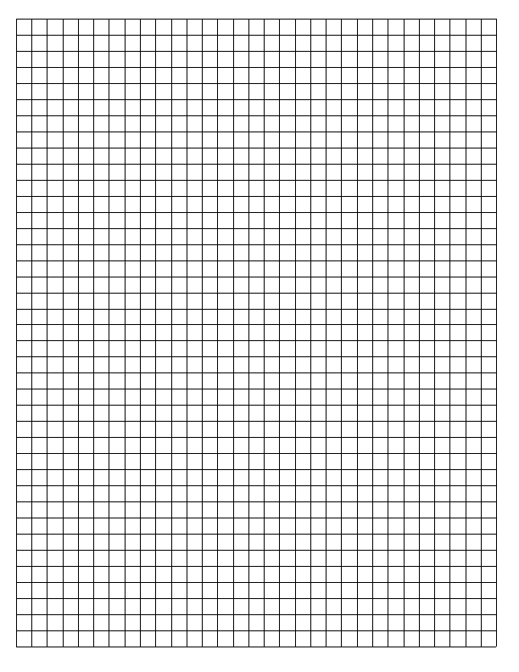

**Number of Students**

**Type of Fingerprint**

**Conclusion:**

1. What is the most common type of fingerprint for our class?
2. Was your hypothesis supported? Why or why not?