**Name____________________________**

**Date __________________ Period ____**

**#______**

**Types of Cells and Protists**

1. Cells are: ______________________________________________________________________________________________________________

2. Types of Cells:

|  |  |
| --- | --- |
| **Eukaryotic Cells** | **Prokaryotic Cells** |
|  |  |

3. Complexity of Organisms:

|  |  |
| --- | --- |
| **Unicellular Organisms** | **Multi-cellular Organisms** |
|  |  |

**Life Functions of Protists**

|  |  |  |  |  |
| --- | --- | --- | --- | --- |
| **Life Function** | **Amoeba** | **Euglena** | **Paramecium** | **Volvox** |
| **How does it move?** |  |  |  |  |
| **How is food taken in?**  **Life Function** | **Amoeba** | **Euglena** | **Paramecium** | **Volvox** |
| **What does it eat?** |  |  |  |  |
| **How does it dispose of waste?** |  |  |  |  |
| **How does it reproduce?** |  |  |  |  |
| **Respiration – Does it take in O2 or CO2?** | O2 | Mostly CO2 | O2 | CO2 |
| **How does it respond to its environment?** |  |  |  |  |
| **Where does it live?** |  |  |  |  |
| **What is its cellular structure?** |  |  |  |  |
| **It is plant-like, animal-like or both?** |  |  |  |  |

**Label and color each diagram according to the text.**

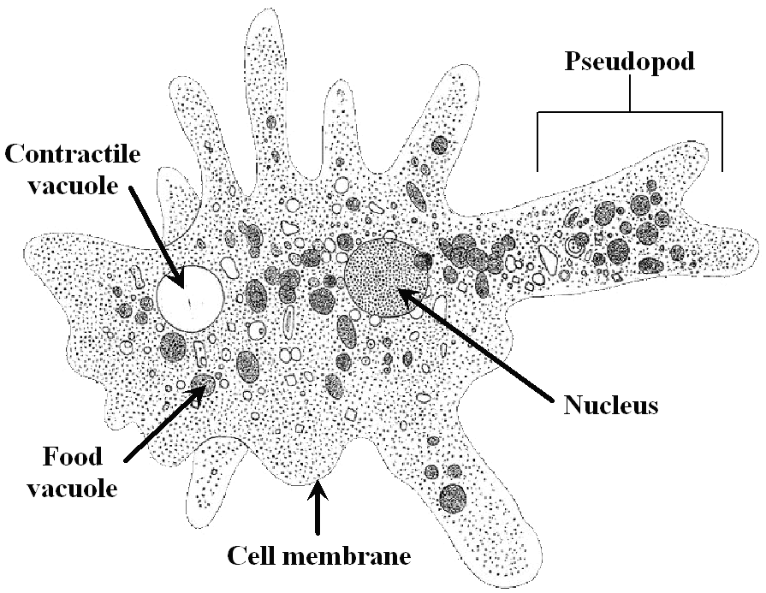

**Amoeba**

* Contractile Vacuole
* Food Vacuole
* Nucleus
* Pseudopod
* Cell Membrane
* (Cytoplasm) Endoplasm
* (Cytoplasm) Ectoplasm

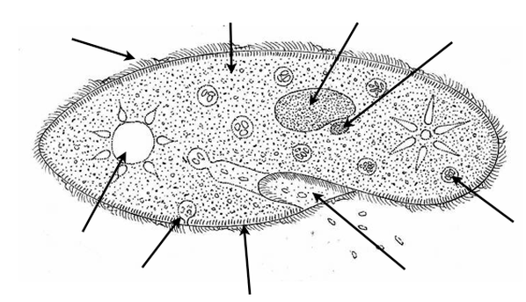**Paramecium**

* Cilia
* Cytoplasm
* Food Vacuole
* Anal Pore
* Contractile Vacuole
* Pellicle
* Macronucleus
* Micronucleus
* Oral Groove
* Gullet

**Euglena**

* Flagellum
* Eyespot
* Reservoir
* Chloroplasts
* Pellicle
* Nucleus
* Contractile Vacuole
* Cytoplasm

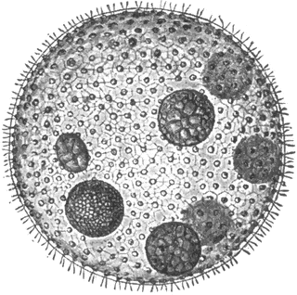

**Volvox Colony**

* Flagellum
* Daughter Colony
* Individual Volvox