**What are Punnett Squares?**

Name _____________________________

Date _________ Item # ________________

Often times, people will refer to a trait or characteristic such as eye color or hair color as being genetic, but what does the word genetic really mean? **Genetics** is the study of heredity and how traits are passed from parents to offspring.

**Heredity** is the process in which traits (characteristics that can be passed only from a living thing to its young) are passed from parents to offspring. A **Punnett square** is a grid system that can be set up and used to predict the possible outcomes that may result from the mating process between two individuals, when their genotypes are known. Each box within the square is representative of one possible genotypic outcome for any offspring; in this example, all offspring will be Bb genotype.

**Male**

**B B**

|  |  |
| --- | --- |
| **Bb** | **Bb** |
| **Bb** | **Bb** |

**b**

**Female**

**b**

The term **genotype** refers to the genetic make-up of an organism. In the diagram above, the genotype of the male is BB and that of the female is bb. Genotype is represented by *using letters* of the alphabet to stand for each allele that has been passed from the parents. A capital letter represents the dominant allele and a lower case letter represents the recessive allele.

**Alleles** are all the forms of a gene for any given trait. There are usually two allele possibilities for every trait. For example: B and b are both alleles for the trait of hair color.

Since genotype is the genetic make-up, **phenotype** is the *physical*result of a gene combination. If, in the above situation, B represents the gene for brown hair, brown hair is said to be a dominant trait. **Dominance** is when one allele can mask the presence of another. For example, all the offspring of the couple in the diagram above will have genotypes of Bb, and they will all have the phenotype of brown hair. This is because the presence of one B, or dominant allele results in the expression of that trait. In a sense, a dominant trait overpowers a recessive one so that only it shows.

So how does a child with blond hair like the mother, bb, result? Since B is dominant, b is a recessive gene. **Recessive** refers to a characteristic that is masked by the presence of a dominant allele. The only way to have a recessive trait expressed is to have both alleles be recessive, bb, resulting in the blond hair color (in this example). Both parents in the square are said to be homozygous. This is because **homozygous** is when the paired alleles for a specific trait are identical. In this case, both parents are homozygous for their trait; the male is BB and the female is bb. Because both parents are homozygous, they can each only pass on one allele type to their offspring. The male can only pass on a B allele and the female, only a b allele. This means that all the offspring will have one B and one b allele and will all be Bb genotype. This Bb genotype is termed as heterozygous. A **heterozygous** genotype is when the alleles that an offspring receives are different, one dominant allele or capital letter and one recessive allele or lowercase letter. In this example, all of the offspring are heterozygous Bb. In addition, the dominant trait or brown hair will be expressed or shown in the offspring.

**How do you set up a Punnett square?**

Let’s run through an example, one step at a time. If you are told that your two dogs are having puppies and you want to figure out what the puppies’ traits might be, there are some things you must know about the parent dogs first. You are told that having pointy ears is dominant over having droopy ears. The mother dog has pointy ears and is heterozygous for that trait. The father dog has droopy ears. E represents the dominant allele for pointy ears, and e represents the recessive allele. Since you are told that the mother is heterozygous, you can immediately assume that her genotype is Ee, because heterozygous means what? That the genes (alleles) present are different from one another.

Add her genes to the Punnett square, along the vertical side. Only one allele is written next to each box on the side and the dominant allele always goes first. See square #1. The next step is to determine the father dog’s genotype. All you were told was that he has droopy ears. But since you know that having droopy ears is a recessive trait, you know that there is only one gene combination that will express such a trait, so you can figure out that he is ee. Add these alleles to the top of the square. Remember, only one allele above each box. See square #2.

**Male**

**e e**

|  |  |
| --- | --- |
|  | Square #1 |
|  |  |

|  |  |
| --- | --- |
|  | Square #2 |
|  |  |

**E**

**Female**

**e**

**E**

**Female**

**e**

Now that the Punnett square is laid out, you can determine the possible genotypes of the offspring. To do this, refer to the example below. Follow each gene at the top and side of the square to the box where they meet. Write the combination in, remembering to always put the dominant gene first.

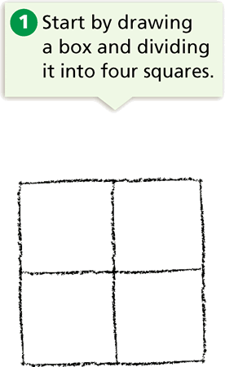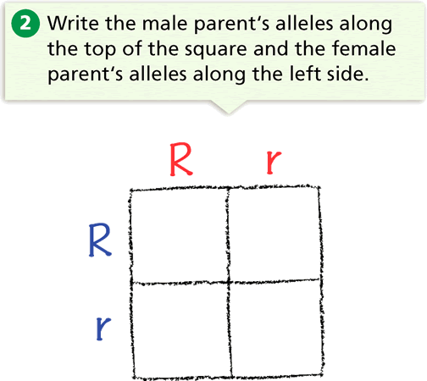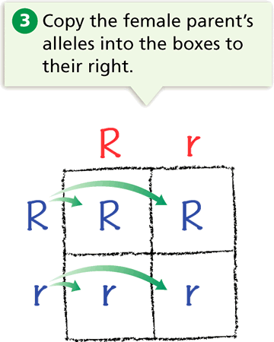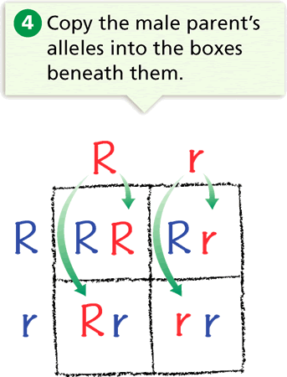

**Male**

**e e**

|  |  |
| --- | --- |
| **Ee** | **Ee** |
| **ee** | **ee** |

**E**

**Female**

**e**

If we complete our Punnett

square for the puppies,

it will look like this.

**What does this all mean?**

This Punnett square shows that there are two possible genotypes for the offspring. They will either be Ee and have pointy ears since E is dominant and masks the recessive gene, or they will be ee and have droopy ears. For an offspring to have a recessive trait expressed, both parents must have at least one recessive allele in their genotype.

**Let’s list the possible genotypes and phenotypes of the offspring for this cross.**

The letters inside the boxes indicate probable genotypes (genetic makeup) of offspring resulting from the cross of these dog parents. There are 4 boxes, and the genotypic results can be written either as fractions or percents. In this case, 2 boxes out of the 4 are showing the Ee genotype. Therefore, each of the offspring has a **2 out of 4, 2/4 or 50%** chance or probability of showing the Ee genotype. The other two boxes are showing the ee genotype. So, each of the offspring also has a **2 out of 4, 2/4 or 50%** chance of having the ee genotype.

We can also figure out the phenotype (physical appearance) that goes with each genotype. Remember, E = pointy ears and e = droopy ears. Since a capital letter indicates a dominant gene, E (pointy ears) is dominant over e (droopy ears). Therefore, each of the offspring has a **2 out of 4, 2/4 or 50%** chance of having either pointy ears (Ee) or droopy ears (ee).